Business Plan- Careers, Futures Forum

Name: Hosai Sadiq, Sara Liu, Lamees Shah

Part 1: Research/ Businesses Name.

Make a list of 5 businesses that you would be interested in starting.
(Food, Childcare, Construction, etc….)

Explain why you would like to start this type of business

 | Type of Business/Name | Why would you like to start this business?
1 | Health care | Most of the businesses that we chose are in the medical field. This is because all three of us; Hosai, Sara, and Lamees, would like our future jobs to be health related. Not only would we be informed about the business aspect, but we’ll be knowledgeable about what goes on inside our building and what is up to date with our patients. Keeping people’s bodies healthy and helping others who have failed to do so, are our goals.
2 | Pharmacies
3 | Nursing
4 | Healthy living
5 | Active body

Mark: /10

Find 5 similar businesses on the internet. Write the name of the business and website address.

 | Business Name | Website Address
1 | Doctors Express  Urgent care when you need it. | http://www.entrepreneur.com/business-opportunities/doctorsexpressurgentcarefranchise/197918.html
2 | Pharmacies:  Drug And Nutrition Stores | http://www.medicalbusinessexchange.com/medical_business_classification/medical_related_business/
3 | Acti-Kare  Responsive in-home care | http://www.entrepreneur.com/business-opportunities/actikareresponsiveinhomecare/198039.html
4 | Visiting Angels  Living assistance service | http://www.entrepreneur.com/business-opportunities/visitingangels/33022.html
5 | Active body  Physical-Therapy | http://www.activebodytherapy.com/meet_our_team.cfm

Mark: /10

Part 2: Company Motto and Mandate.

Make a list of 10 services or products your company will provide customers.

 | Item |  | Item
1 | Needles | 6 | Baths
2 | Bandages | 7 | Massage Therapy
3 | Drugs | 8 | Hand sanitizer
4 | Food & Water | 9 | Paper cups & vending machines
5 | Help | 10 | Hospital Gowns, Linens, Uniforms, Apparel & Clothing

Mark: /10

Motto: 1 sentence summarizing your business. What is the most important thing your business does?

We provide YOU the most care!

Mandate: 1-2 Paragraph Description of Goals and Services. Describe all of the things your business will do for customers/ clients. Everything should build from the most important thing your business does.

The main goal of our business is to provide the most care to our residents and employees. Our business provides the mandatory items such as bandages, needles, drugs, puffers, scrubs, apparel and clothing to individuals who come in the hospital. Along with these items, we perform massage therapy on individuals. The service assists us, by providing our hospital with the medical instruments such as Sphygmomanometer, Thermometer, Ophthalmoscopes, drugs/Medication, Ultrasound Machine, Stethoscope, and much more. It is our job to provide the best and the most.

Mark: /10

Part 3: Budget & Supplies
Make a list of 20 items that your company will need to get started and include a price for each (space rental, website, food, tools, etc….)

Note:
Include the price per month for rentals x 12
Include a gas/ mileage calculation per kilometer for vehicles and estimate how many kilometers you will be travelling per month.

 | Item/ Price |  | Item/ Price
1 | Sphygmomanometer/ $1959.60x12= $23515.20 | 11 | Thermometer/ $649.50x12= $7794.00
2 | Needles/  -Exel 10ml with18g, x1 inch needle (Qty. 800) $279.60x12= $3355.20 | 12 | Ophthalmoscopes/ $6285.00x12= $75420.00
3 | Bath towels/ $150.00x12=$1800.00 | 13 | Wheelchair/ $3870.00x12= $46440.00
4 | Puffers/ $3500.00x12= $42000.00 | 14 | Magazines/ and toys for kids  -Toys and magazines are donated.
5 | Drugs/Medication/ $4000.00x12=$48000.00 | 15 | vending machines/ $4,495x2= $8990.00  (We’ll have 2 per year)
6 | Food & Water/ $810.00x12=$9720.00(juices, Popsicles) | 16 | Educational utensils (Pencil, paper, pen, rulers) $41.67x12 =$500.00
7 | Hospital Gowns, Linens, Uniforms, Apparel & Clothing/  - 42x52 Straight Back, (Qty. 300) $43.95x12= $527.40 | 17 | Bathroom items such as toilet paper, paper towels, soaps, and hand dryers/  bathroom items/ $451.67x12=$5420.00
8 | Scrubs/ $75.00x12= $900.00 | 18 | Face mask/ (Qty, 20) $19.29x12= $231.48
9 | Ultrasound Machine/ $8,400.00  (we’ll have one per year) | 19 | Bed prevention covers/ $25.10x12=$301.20  Pillows/ $1000x12=$12000
10 | Stethoscope/$726.00x12= $8712.00 | 20 | Beds/$225.00x40=$9000.00  (we’ll have 40 per year)

Calculate the start up costs for your first year of business.
Total Costs: $313,026.48

Mark: /10
Part 4: Employee Information

Make a list of 5 jobs that you will need in order to properly run your business. (Cook, Cashier, Supervisor)
Write a description for each job.

 | Type of Job | Job Description
1 | Physiologists | These are doctors of life science who specializes in physiology.
2 | Oncologist | An oncologist is a doctor who treats cancer patients.
3 | Dentist | Dentists are doctors who help individuals with dental health, teeth and dental problems like cavities and bleeding gums. They help in treating gum diseases, straightening teeth, carrying out root canals.
4 | Neurosurgeon | These doctors help in treating the nervous system diseases that can be cured or controlled to some extent with mechanical intervention.
5 | Cardiologist | These doctors are known for diagnosing and treating heart diseases and cardiovascular diseases.
Along with the different types of doctors, our hospital has many other different types of jobs such as cooks, custodian, and supervisor.

Mark: /10

Calculate the hours of operation, number of employees working during shifts, and wage per hour.

Day/ Hours | No. Employees/ Wage pr Hour | Amount of Wages per Day
Mon, Hours:  6:00am-6:00am  Total Hours:24 | Number:127  Wage per hour:20  Total:1524 | Total Day/ Hours  x  Employee Wages Total: 1200
Tues, Hours: 6:00am-6:00am  Total Hours:24 | Number:133  Wage per hour:20  Total: 2660 | Total Day/ Hours  x  Employee Wages Total: 1200
Wed, Hours: 6:00am-6:00am  Total Hours:24 | Number:118  Wage per hour:20  Total:2360 | Total Day/ Hours  x  Employee Wages Total: 1200
Thurs, Hours: 6:00am-6:00am  Total Hours:24 | Number:107  Wage per hour:20  Total:2140 | Total Day/ Hours  x  Employee Wages Total:1200
Fri, Hours: 6:00am-6:00am  Total Hours:24 | Number:142  Wage per hour:20  Total:2840 | Total Day/ Hours  x  Employee Wages Total: 1200
Sat, Hours: 6:00am-6:00am  Total Hours:24 | Number:102  Wage per hour:20  Total:2040 | Total Day/ Hours  x  Employee Wages Total: 1200
Sun, Hours: 6:00am-6:00am  Total Hours:24 | Number:101  Wage per hour:20  Total:2020 | Total Day/ Hours  x  Employee Wages Total: 1200
 | Total Wages per week: 15,584

Mark: /10

Part 5: Promotion

Business Cards

3 Thumbnail Designs Mark: /5
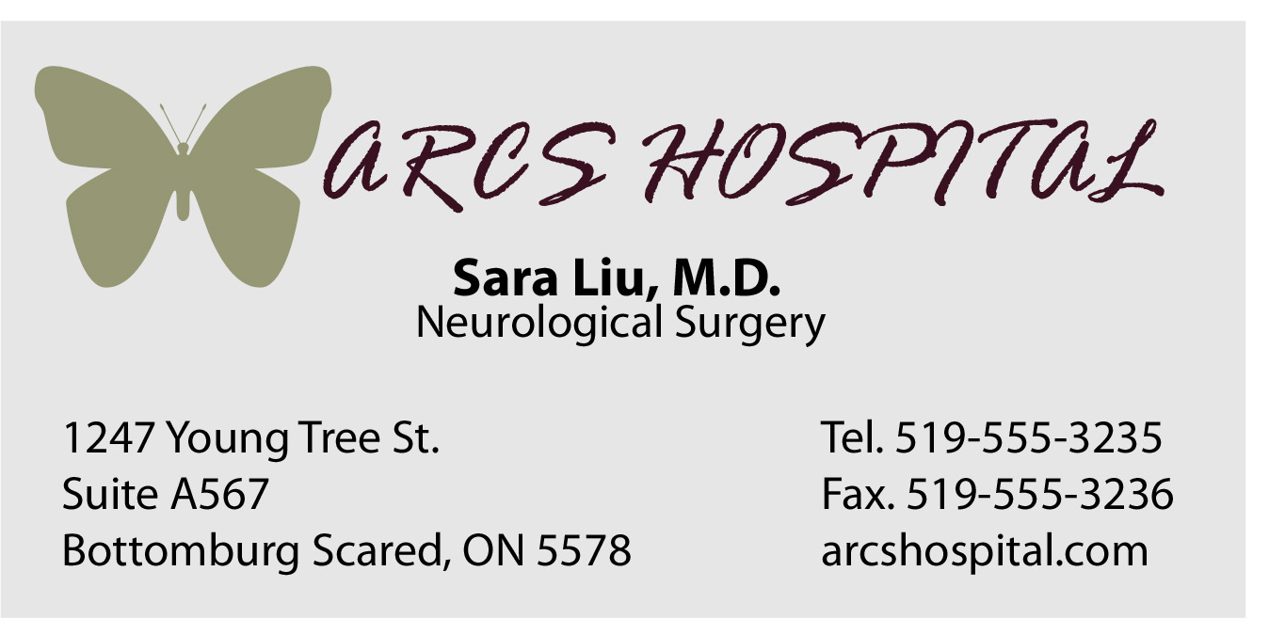




Computer Design (or detailed drawing) done in Photoshop, Publisher, or other graphics software

Final Business Card (attach print out or detailed drawing) Mark: /10

FINAL DESIGN:

Poster Design

3 Thumbnail Designs (with colour) Mark: /5
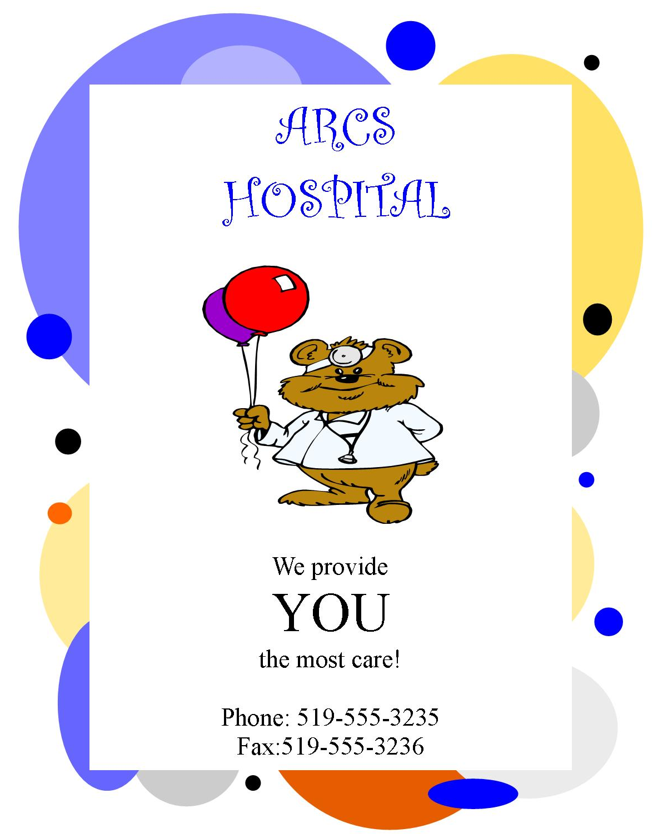
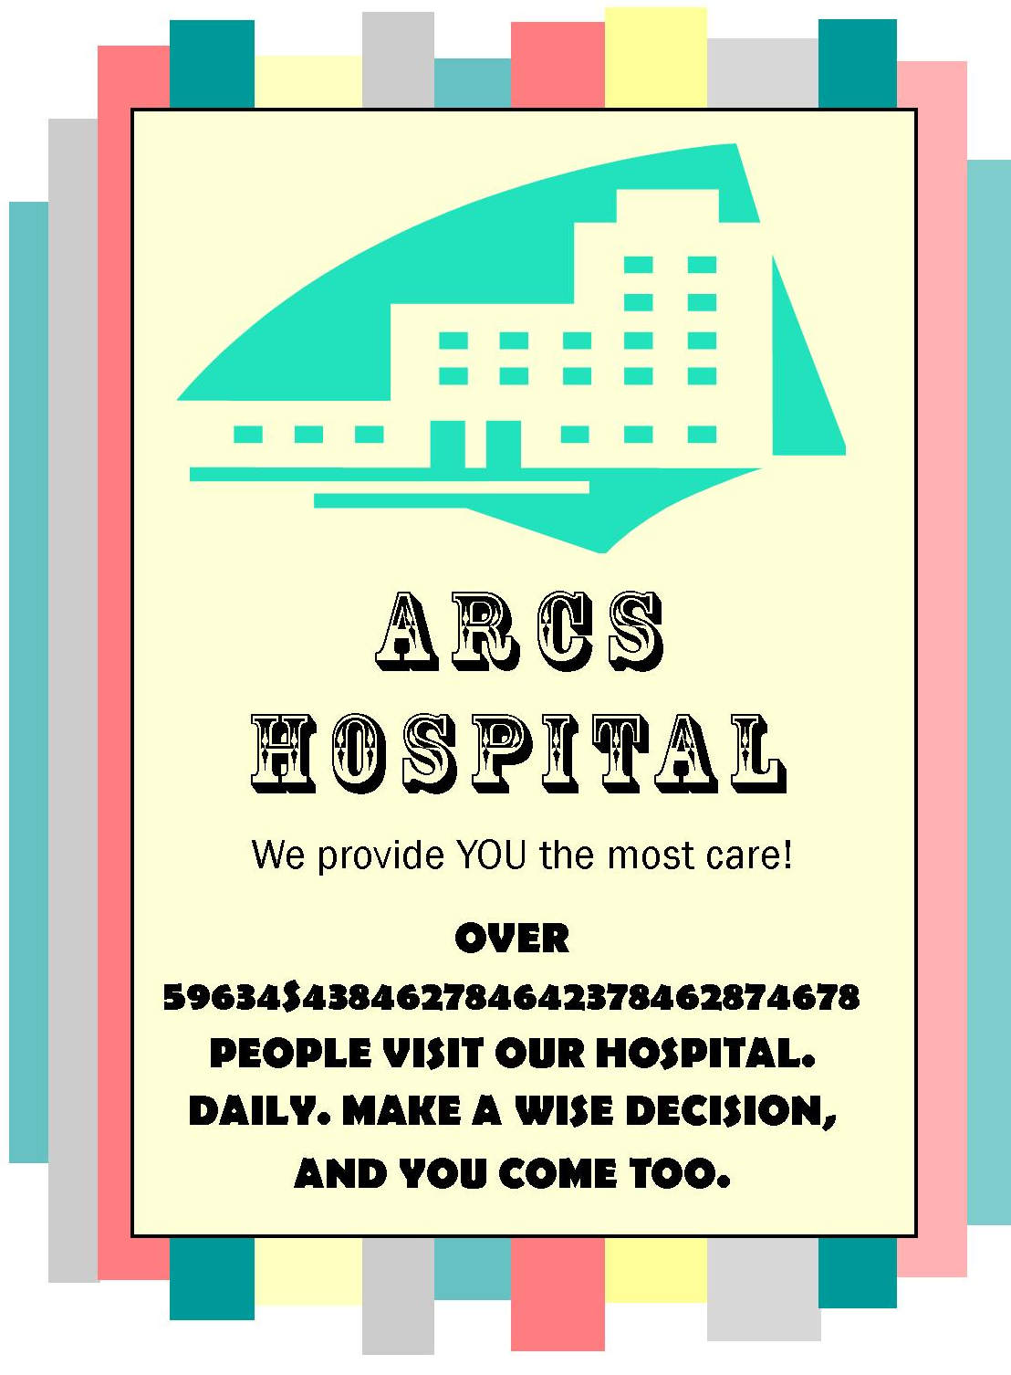


Computer Design (or detailed drawing) done in Photoshop, Publisher, or other graphics software

Final Poster Design (attach print out or detailed drawing) Mark: /10
FINAL DESIGN:

Total: /100

